**Topics: Descriptive Statistics and Probability**

1. Look at the data given below. Plot the data, find the outliers and find out $μ, σ, σ^{2}$

|  |  |
| --- | --- |
| **Name of company** | **Measure X** |
| Allied Signal | 24.23% |
| Bankers Trust | 25.53% |
| General Mills | 25.41% |
| ITT Industries | 24.14% |
| J.P.Morgan & Co. | 29.62% |
| Lehman Brothers | 28.25% |
| Marriott | 25.81% |
| MCI | 24.39% |
| Merrill Lynch | 40.26% |
| Microsoft | 32.95% |
| Morgan Stanley | 91.36% |
| Sun Microsystems | 25.99% |
| Travelers | 39.42% |
| US Airways | 26.71% |
| Warner-Lambert | 35.00% |

Mean = 33.27

standard deviation = 16.97

Variance = 287.1466

Outlier = 91.36

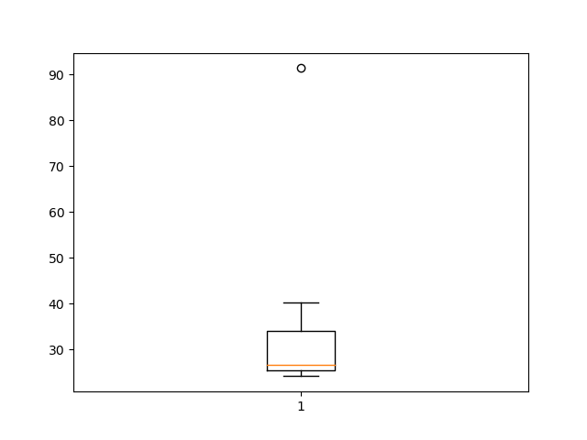

point far away from boxplot represents outlier in our data



Answer the following three questions based on the box-plot above.

1. What is inter-quartile range of this dataset? (please approximate the numbers) In one line, explain what this value implies.

Upper extreme = 19

Lower extreme = 0

Q1 = 5

Q2 = median = 7

Q3 = 12

Outlier data = 25

inter-quartile range = Q3 – Q1 = 12 – 5 = 7

inter-quartile range use in our data is divide in which range and if any outlier in our data set then inter-quartile range is provided .

1. What can we say about the skewness of this dataset?

Here , Data has divide is right side and tail is at right side( POSITIVE – SKEWED )

1. If it was found that the data point with the value 25 is actually 2.5, how would the new box-plot be affected?

if we remove outlier data point from box-plot then value of ( Q3-Q2) will dicrease and (Q2-Q1) will increase after that if we add 2.5 value to box-plot then again Q2 will tends to Move in Q3 direction which results in data tends to be normally distributed.



Answer the following three questions based on the histogram above.

1. Where would the mode of this dataset lie?

Ans - Dataset lie between 4 to 8.

1. Comment on the skewness of the dataset.

Ans - POSITIVE SKEWED

1. Suppose that the above histogram and the box-plot in question 2 are plotted for the same dataset. Explain how these graphs complement each other in providing information about any dataset.

Ans - From both histogram and box plot we can find mean, positive skewness (same nature of

Distribution) and 25 is outlier . outlier is easy to identity in histogram .

1. AT&T was running commercials in 1990 aimed at luring back customers who had switched to one of the other long-distance phone service providers. One such commercial shows a businessman trying to reach Phoenix and mistakenly getting Fiji, where a half-naked native on a beach responds incomprehensibly in Polynesian. When asked about this advertisement, AT&T admitted that the portrayed incident did not actually take place but added that this was an enactment of something that “could happen.” Suppose that one in 200 long-distance telephone calls is misdirected. What is the probability that at least one in five attempted telephone calls reaches the wrong number? (Assume independence of attempts.)

Ans - : probability = (1/200) * 5 = 1/40 = 0.025

1. Returns on a certain business venture, to the nearest $1,000, are known to follow the following probability distribution

|  |  |
| --- | --- |
| x | P(x) |
| -2,000 | 0.1 |
| -1,000 | 0.1 |
| 0 | 0.2 |
| 1000 | 0.2 |
| 2000 | 0.3 |
| 3000 | 0.1 |

1. What is the most likely monetary outcome of the business venture?

Ans - The most likely monetary outcome of the business venture: x = 2,000 with the highest probability of 0.3

1. Is the venture likely to be successful? Explain

Ans - because (x = 1,000) + (x = 2,000) + (x = 3,000)

= 0.2+ 0.3 + 0.1 = 0.6

1. What is the long-term average earning of business ventures of this kind? Explain

Ans - ( 0.1)(−2,000) + (0.1)(−1,000) + (0.2)(0) + (0.2)(1,000) + (0.3)(1,000) +(0,1)(3,000)

= 800

1. What is the good measure of the risk involved in a venture of this kind? Compute this measure

Ans - prob(x>=0) = prob(0) + prob(1000) + prob(2000) + prob(3000)

= 0.2 + 0.2 + 0.3 + 0.1

= 0.8

Standard Deviation is the good measure of the risk involved in a venture of this kind.

Compute Standard Deviation:  
 In Assignment-2-Set1-Q5 (Basic Statistic Level-2).ipynb